Bioelectricity in plants: Laboratory Protocol

Designed by
Kaitlyn Brock, Matthew Thomas, D. Nicholas McLetchie & Robin L. Cooper
Movie of the lab https://youtu.be/sEdBDbmVQ_s
Introduction
Ever since the discovery of bioelectricity in animals by Volta and Galvani (McComas, 2011), there has been a fascination of the origin and purpose of electrical signals in organisms. Organisms can relay information in various ways within themselves as a means of controlling cellular function and communicating among cells. This communication is commonly associated with electrical signals. These signals are associated with a change in membrane potential of a cell which is a charge difference across a cell membrane. For example, changes in membrane potential of muscle or a nerve leads to the conduction of the electrical signal to regulate muscle contraction or relaying information to a target. Membrane potential changes occur due to the movememt of ions across a membrane through protein channels. The flow of ions (or current) can be monitored by changes in the electrical field produced as a difference in electrical potential . A common approach to measure of ionic movement across membranes of cells in skeletal muscle, heart muscle or brain using an electromyogram (EMG), electrocardiogram (ECG), and electrocardiogram (ECG). In such cases, the electrical signals are monitored over the body due to ionic movements within the associated tissue, but the field potential is detected away from the associated tissue. Not only can field potentials be detected in animals but also in plants. Movements of fluids containing ions within xylem, phloem or across cell walls also generate static and dynamic electric fields (Fromm and Lautner, 2007).
Streaming of fluid movements within compartments (i.e., tissues, cellular compartments) of a plant produces what are termed as streaming potentials (Gilbert et al., 2006; Gensler and Yan, 1988; Koppan et al., 1988; Labady et al., 2002).
Membrane potential changes within a plant can produce electrical fields which can be monitored around areal parts of the plant in the air (Pietak, 2011; Frohlich, 1968a,b, 1975 ) as well as around the roots (i.e., water, soil) (Love et al., 2008).
Nevertheless, measurements on the surface or within a plant provide a better ability to measure membrane potential changes as the signals are not as dissipated in the surrounding environment. Such focus measurements to assess ionic movements within the plant can potentially detect cellular activity in response to photosynthesis, injury, and response to environmental changes (ref).
The goals of this laboratory exercise is to understand how organisms can generate electrical potentials and in particular to measure electrical signals by plants and animals by various approaches to learn how such measures are made and related concepts related to bioelectricity.
Two different electrophysiological approaches are to be used and compared in this first part of the exercise in measuring electrical potentials of plants. One approach uses a standard intracellular glass microelectrode technique as a differential recording to a ground lead and another is an impedance measure to detect a change in resistance between two points which results in voltage changes when current is kept constant per Ohm’s Law. The standard differential electrical measure, commonly used for animal cells, is to detect a voltage change between recording lead (glass microelectrode) and a ground lead ; however, if the recording lead does not have high enough resistance, then small changes in ionic flow (current) are hard to detect. If both the ground and recording leads are immersed within a solution with a large surface exposure on the recording lead, then this will result in a low resistance input. Thus, a reason to have a small area of contact with the tissue being measured is to have a high resistance allowing small changes in current to result in a larger voltage change as established by Ohm's law. Essentially, the smaller the area of contact the greater the resistance. A high resistance recording lead can be obtained by coating the lead with an insulation while leaving a small amount of wire exposed at the tip, or placing the recording lead with more surface exposure within a glass microcapillary which has a small tip opening to the media being measured. In this procedure, the microcapillary is filled with a conductive media such as 3M potassium chloride (KCl) or potassium acetate as typically used for recordings across cell membranes in animal tissue. For recordings within compartments (i.e, chambers such as xylem and phloem within a plant) and within cells of plants a common practice is to use 0.3 or 0.1 M KCl within the recording glass microcapillary (Yan et al., 2009; Fromm and Lautner, 2007). This first technique measures voltage where the plant produces a current and has a given resistance. Ohm’s Law : V = IR: where V= voltage, I = current, and R = resistance .
This first approach for electrophysiological recording is susceptible to field potentials in the environment such as 50 (Europe) or 60 (North America) Hz frequency from electronic equipment. Thus, a Faraday cage is commonly used for such recordings to shield the environmental electrical noise.
The second electrophysiological approach is an impedance measure and is similar to the differential recording mentioned above. Two leads are used to detect a change in voltage difference due to a change in resistance. This is often referred to as a measure of dynamic resistance. With the impedance measure two leads are used to detect a change in resistance while passing a constant current. Impedance measures are used in various ways such as respiratory breathing rates with expansion and relaxation of a chest for mammals (Bachmann et al., 2018), the movements of a respiratory organ in crayfish to control aeration of gills (Schapker et al., 2002), clinical neuromuscular disease research in mammals (Nagy et al., 2019), the heart rate of crustaceans submerged in water (Listerman et al., 2000; Li et al., 2000), as well as to detect when the environment causes physiological stress of crayfish, crab or shrimp (Weineck et al., 2018).
Even the fine movements of a beating heart in larval Drosophila can be detected as there is a wide range in the sensitivity with an impedance technique without detecting surrounding electrical noise. Depending on how the measures are made, they can be noninvasive, such as a strap around the chest of a mammal or two leads in the media to detect body movements of insect larvae (Cooper and Cooper, 2004; de Castro and Cooper, 2020).
With two leads in a media or solution with an organism or a tissue present, a small electrical field can be used. If there is any change in the resistance between the two leads, such as the movement of ions, this will be detected.
Herein, we used these to electrophysiological approaches to measure electrical changes due to ionic movement within a plant during injury and one can even exposure various compounds to the roots of the plant if time allows. Other measures can be recorded such as the response of a healthy plant to stimuli and disease states, and ionic movements within the plant that occur during metabolic processes such as photosynthesis. Such measures are not only possible for acute changes within milliseconds but monitoring long term recordings over days, weeks, and months are feasible.

Methods of electrophysiology

List of material needed for 1 set up:

- Scissors (1)
- Forceps (1)
- Silver Wire for ground wire (1)
- Conductive paint
- Microscope (1)
- Electrode Probe for intracellular measures(1)
Glass electrode and KCl solution to fill electrode
Amplifier/Acquisition System (1)
- Faraday Cage (1)
- Desktop/Laptop (1)
- Plant anchored as not to move (1)
- A micromanipulator to hold electrode probe.

Electrophysiology using the standard intracellular technique
Measuring electrical responses within the stems of plants will be performed by inserting a glass microelectrode (catalogue # 30-31-0 from FHC, Brunswick, ME, 04011, USA) with tips broken to jagged openings in the range of 10 to 20 µM diameter. The electrode will be filled with 0.3 mM KCl). A ground wire will be placed in the moist soil next to the plant being recorded or attached to the plant with conductive paint. The electrical signals will be obtained with an amplifier (Neuroprobe amplifier, A-M systems from ADInstruments, Colorado Springs, CO. 80906 USA) and connected to a computer via an AD converter (4s Power lab 4/26, ADInstruments, Colorado Springs, CO. 80906 USA) (Figure 7). Recordings will be performed at an acquisition rate of 20 kHz. Events will be observed and analyzed with software Lab-Chart 8.0 (ADInstruments, USA).
The silver wires of the recording and ground wire will be coated with chloride by using bleach for about 20 minutes to obtain the Ag-Cl coating. All wires are rinsed thoroughly with water prior to being used. A g lass electrode is to be placed within the stems with a micromanipulator under a dissecting microscope. The electrodes were inserted 1 to 2 mm into the stem of the plants (Figure 1&2). The recording set up is performed within a grounded Faraday cage as shown in the YouTube link: https://youtu.be/Jv7XYhu-kCs

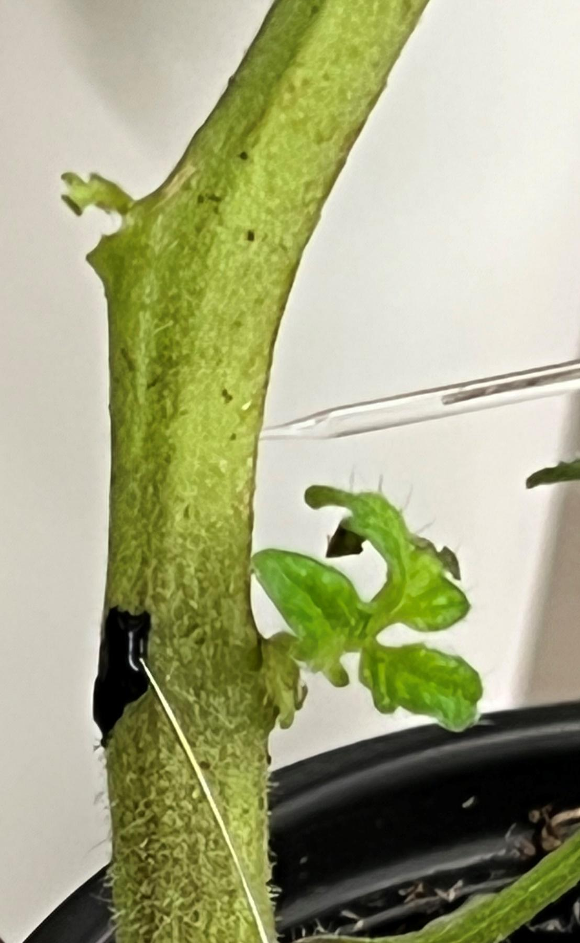
Figure 1: A representative tomato plant with a glass electrode placed within the stem and the ground wire attached to the stem with conductive black paint.
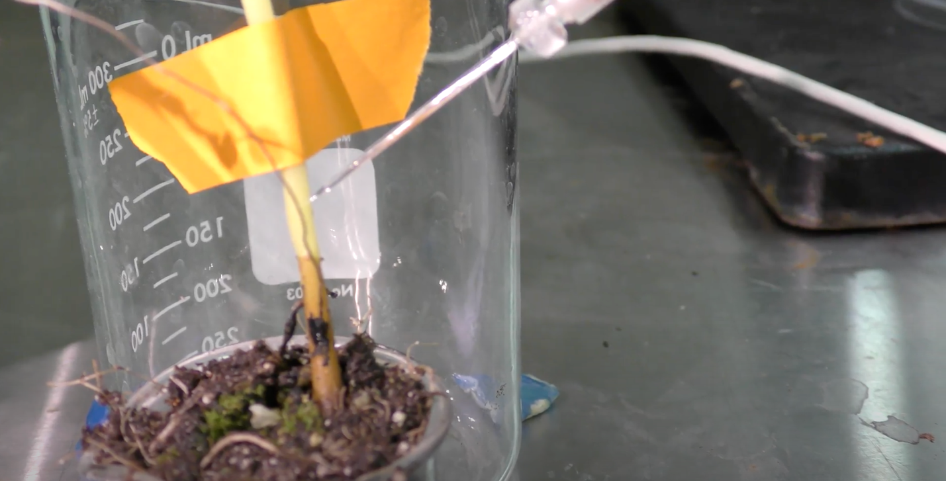
Figure 2: A representative Coleus scutellarioides with a glass electrode placed within the stem and the ground wire attached to the stem with conductive paint. Here the stem is taped to a beaker for stabilizing the stem.
Electrophysiology using the impedance technique
The impedance technique is used for the plant model of choice (Coleus scutellarioides). Two insulated iridium-platinum wires (diameter 0.127 mm and with the coating 0.2032 mm; A-M Systems, Carlsburg, WA, USA) or insulated stainless steel wires (0.127 mm diameter and with coating 0.2032 mm diameter; A-M Systems, Carlsburg, WA, USA) can be used. The iridium-platinum wires are more flexible than the stainless steel wires, but the stainless steel wires are preferable due to the stiffness of steel in penetrating the stem of the plant. In addition, the stainless steel wires are about a third of the cost. The insulation (~ 0.5 mm length) was removed with fire on the ends of both wires to be in contact with the plant. The other ends had the insulation removed (~ 1 cm) to be placed in the clamps of the impedance amplifier. The impedance amplifier (model 2991, UFI, Morro Bay, CA, USA, Figure 8) was used, which allowed changes in an electrical field to be monitored as a measure of dynamic resistance.
Two approaches will be used for impedance measures. One approach involves placing the two leads along the stem of the plants with physical contact, but not penetrating the tissue. In this case, the conductive paint was applied sparingly over the exposed ends of the wires and on the plant. A second approach was to impale the stem of the plants with both leads to a depth of about 1 mm or less. The two leads were 5 to 10 cm apart. The output of the impedance amplifier was connected to a computer via an AD converter (4s Power lab 4/26, ADInstruments, Colorado Springs, CO. 80906 USA). Recordings were performed at an acquisition rate of 20 kHz for acute measures and at 100points/sec for long term recordings over hours. Events were observed and analyzed with software Lab-Chart 8.0 (ADInstruments, USA). Figure 3 illustrates the impaling approach with the impedance wires.
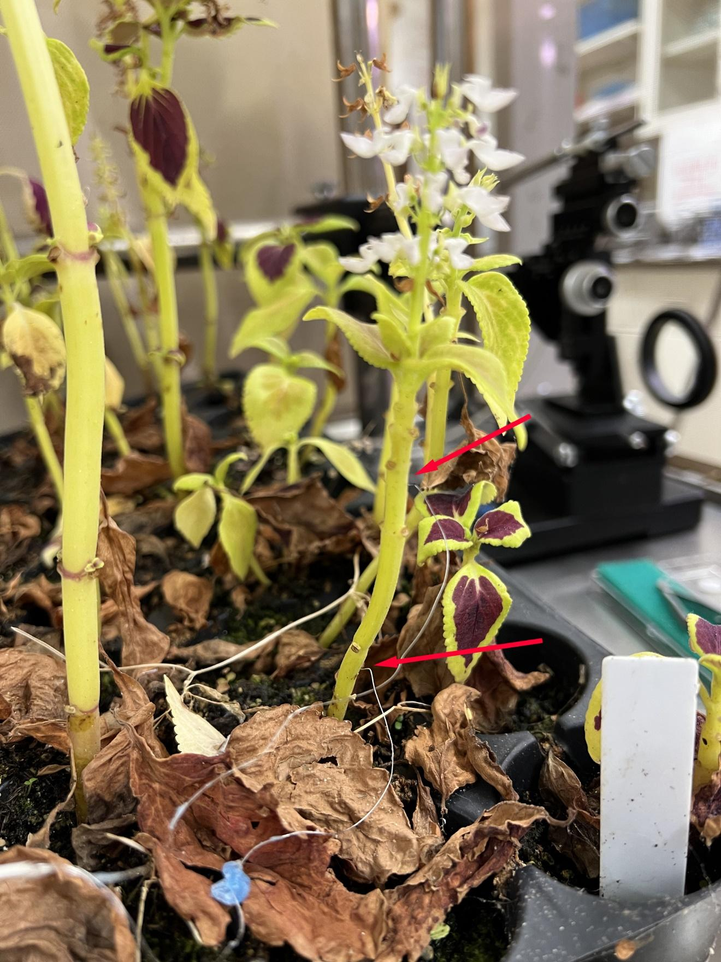
Figure 3: Coleus scutellarioides showing the two leads for impedance measures. The two leads are placed about 1 mm within the stem and are about 6 cm apart.
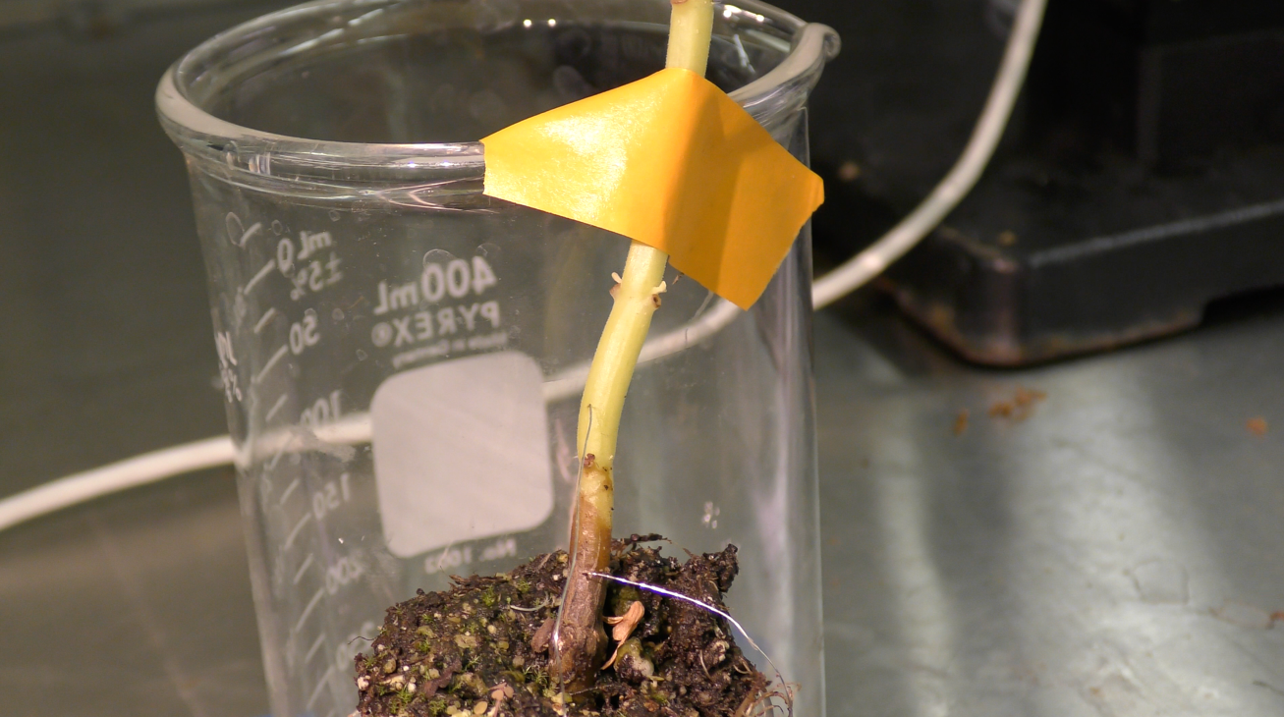
Figure 4: Impedance wires placed in (penetrated) the stem of Coleus scutellarioides.

Stimuli
- Injury induction
Can changes in electrophysiology as a result of mechanical injury? We will cut the leaf with a scissors to test for electrophysiological changes. Because cutting a leaf with a scissors requires the leave to move, we will test if leaf movement without cutting results in electrophysiological changes. This will be tested by bending the leaf to the same degree as would occur by cutting the leaf. Leaves are to be taped to a supporting structure to avoid any movement of the stem where the recording leads will be placed. (Figure 5 to 8)
The associated videos and figures illustrate some of the leaf bends and cuts to be performed. https://youtu.be/sEdBDbmVQ_s

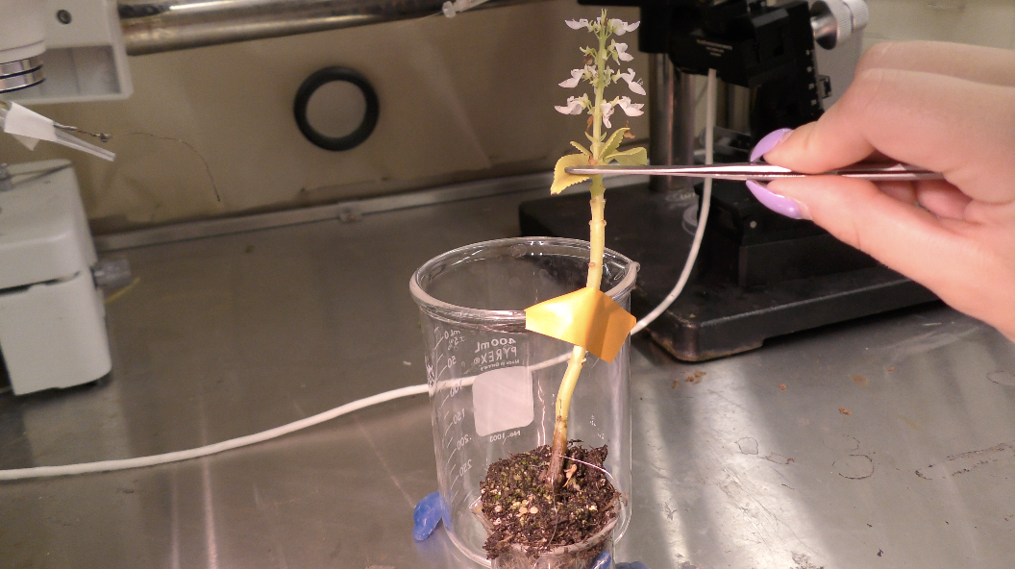
Figure 5: Bending a leaf while recording using impedance technique.
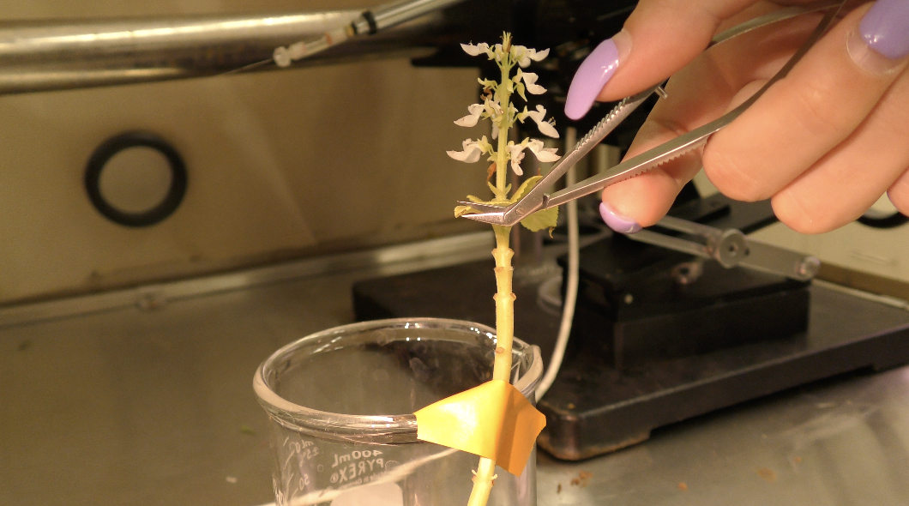
Figure 6: Cutting a leaf while recording with impedance technique.
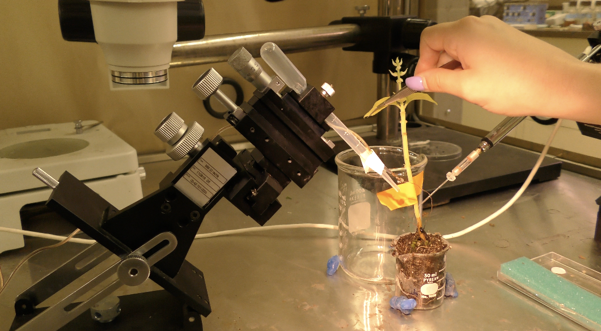
Figure 7: Bending leaf using glass electrode technique
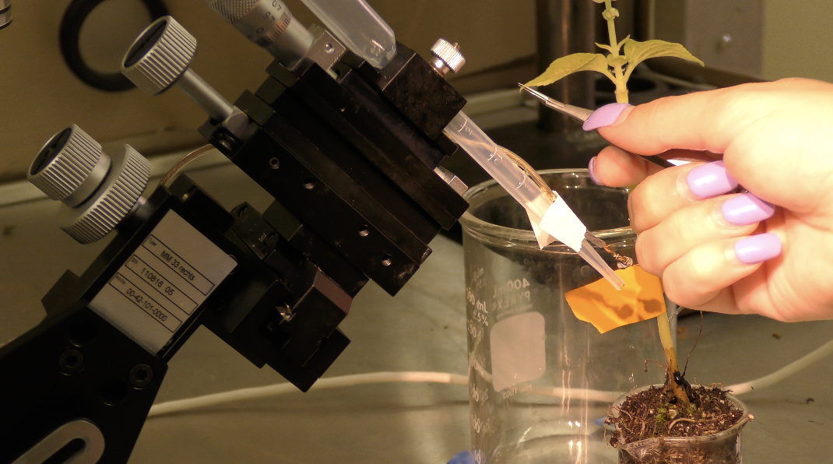
Figure 8: Cutting leaf using glass electrode technique

Electrical recording
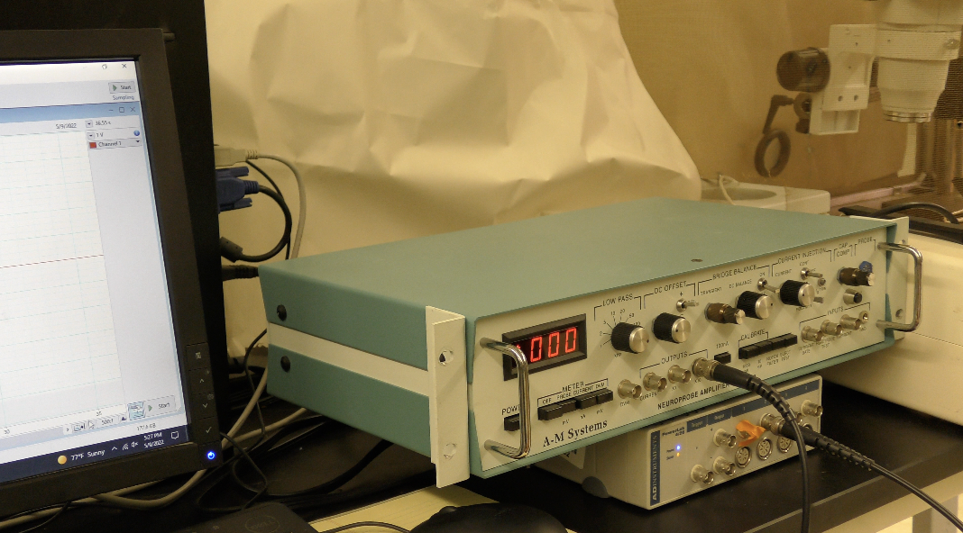
Figure 9: The amplifier used for the glass electrode technique
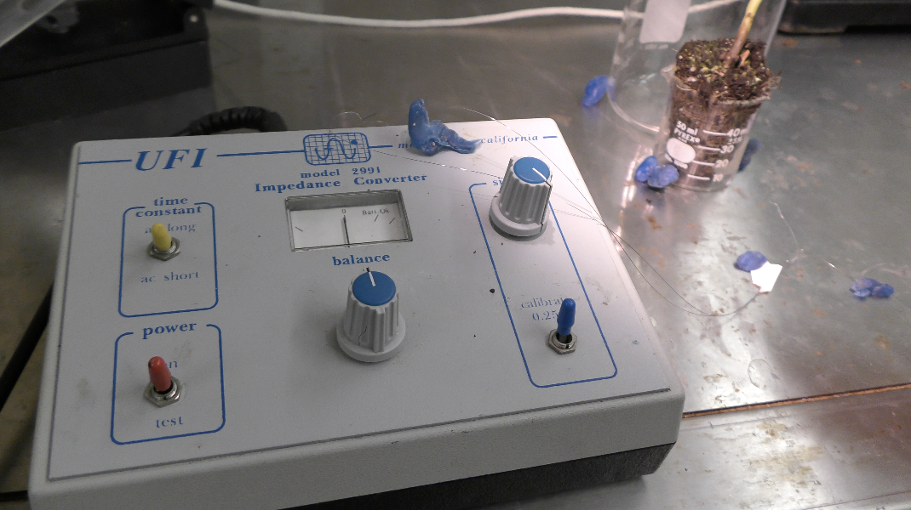
Figure 10: An impedance converter
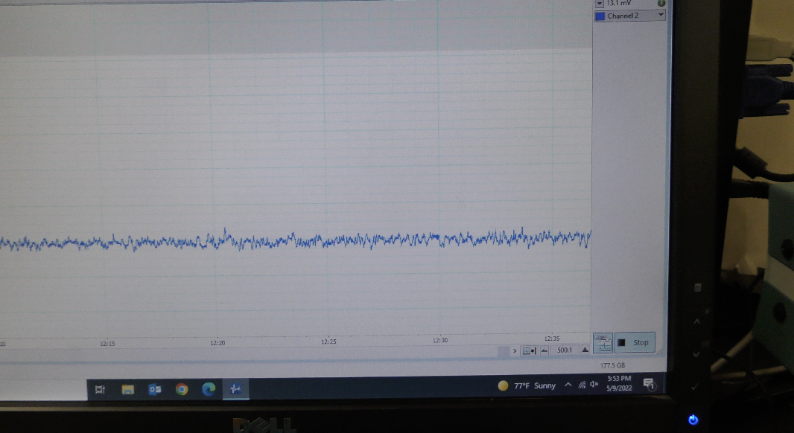
Figure 11: Screen response from bending with impedance. No deflection in the trace is correlated with bending of the leaf.
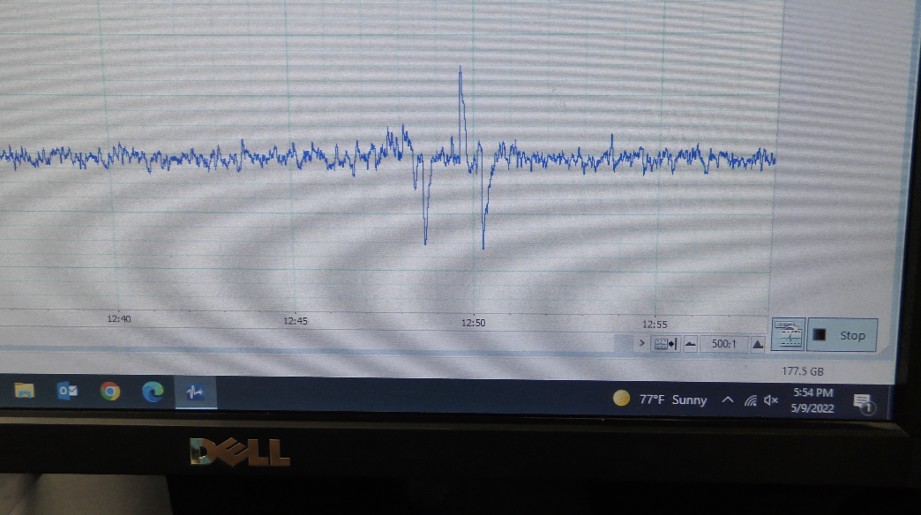
Figure 12: Screen response from cutting a leaf while measuring the responses with the impedance technique.
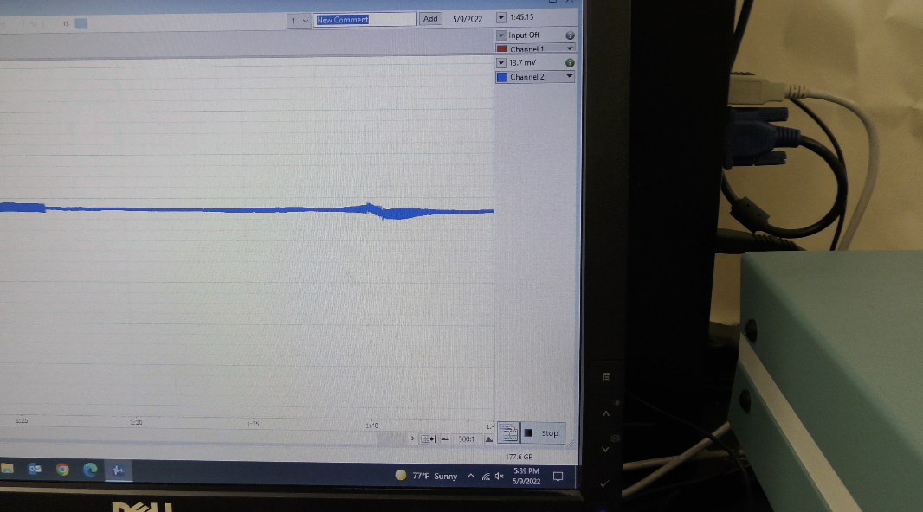
Figure 13: Screen response from bending a leaf while using the glass electrode.
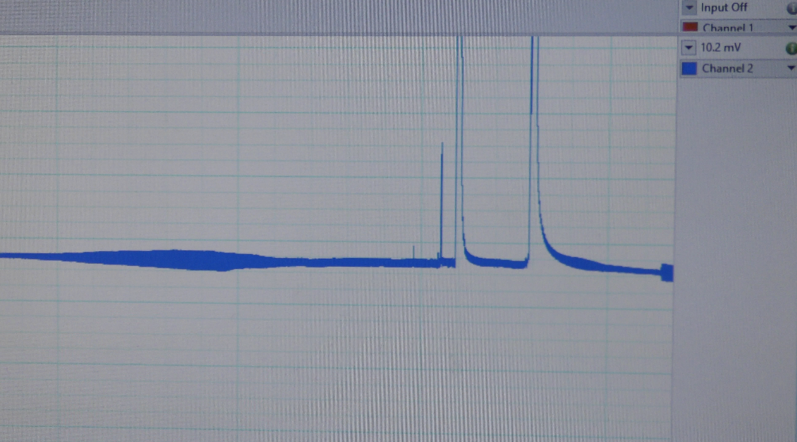
Figure 14: Screen response while making a cut on a leaf while using the glass electrode.

Analysis
Measure the amplitude of responses related to bending a leaf and cutting a leaf with the different recording techniques. Place a marker at the base of response and move the cursor over the trace to measure the difference. Record the values in notebook and on the white board for other groups and you your data.

Discussion points
1. Was there a difference between touching the leaves and cutting the leaves across both approachs
2. Of the two approaches to measure electrophysiological response which of the two are better? Why?
3. What is causing the electrical responses in plants?
4. Is this electrophysiological information useful for the plant? If so, how do you know? How can you prove that the information is used by the plant?
5. Would different plants give different responses to same stimuli?
6. Hypothesize how plants might electrically communicate with each other ?

Part 2: Electrical responses from animal tissue
Extracellular recording of animal tissue
See the associated movie with this module in how to record an EMG in a human with the EMG Spiker box from Backyard Brains. https://youtu.be/sEdBDbmVQ_s

Intracellular recording of animal tissue
The next exercise is to record the resting membrane potential in animal tissue. Please see this detailed protocol for recording membrane potentials in crayfish muscle.
https://web.as.uky.edu/Biology/faculty/cooper/Bio450-AS300/K%20and%20Na%20lab/LAB-RP.htm

References
Bachmann, M.C.; Morais, C.; Bugedo, G.; Bruhn, A.; Morales, A.; Borges, J.B.; Costa, E.; Retamal, J. Electrical impedance tomography in acute respiratory distress syndrome. Crit. Care 2018, 22, 263.

Cooper, A.-S.; Cooper, R.L. Monitoring activity of Drosophila larvae: Impedance & video microscopy measures. Drosophila Infor. Service 2004, 87,v85-87.

de Castro, N.S.; Cooper, R.L. Useful techniques for measures with Drosophila: larval movements, heart rate, and imaging. Methods and Protocols 2020, 3(1), 12; https://doi.org/10.3390/mps3010012
Frohlich, H. Bose condensation of strongly excited longitudinal electric modes. Physics Letters A 1968, 26A, 402-403.
Frohlich, H. Long-range coherence and energy storage in biological systems. International J. of Quantum Chemistry 1968, 2, 641-649
Frohlich, H. Evidence for bose condensation-like excitation of coherent modes in biological systems. Physics Letters A. 1975, 51A, 21-22
Fromm, J.; Lautner, S. Electrical signals and their physiological significance in plants. Plant Cell Environ. 2007, 30(3), 249–257. https://doi.org/10.1111/j.1365- 3040.2006.01614.x.
Gensler, W.; Yan, T. Investigation of the Causative Reactant of the Apoplast Electropotentials of Plants. J. Electrochemical Society: Electrochemical Science and Technology. 1988, 135, 2991–2995.
Gilbert, D.; Mouel, J.L.L.; Lambs, L.; Nicollin, F.; Perrier, F. Sap flow and daily electrical potential variations in a tree trunk. Plant Science. 2006, 171, 572–584. [Google Scholar]
Koppan, A.; Szarka, L.; Wesztergom, V. Conclusions from multichannel electrical recordings in a standing tree. Ann. Geophys. 1998, 16, 271
Labady, A.J.; Thomas, D.J.; Shvetsova, T.; Volkov, A.G. Plant bioelectrochemistry: effects of CCCP on electrical signaling in soybean. Bioelectrochemistry. 2002, 57, 47–53.
Li, H.; Listerman, L.; Doshi, D.; Cooper, R.L. Use of heart rate to measure intrinsic state of blind cave crayfish during social interactions. Comp. Biochem. Physiol. A 2000, 127, 55-70.

Listerman, L.; Deskins, J.; Bradacs, H.; Cooper, R.L. Measures of heart rate during social interactions in crayfish and effects of 5-HT. Comp. Biochem Physiol A. 2000, 125, 251-264.

Love, C.J.; Zhang, S.; Mershin, A. Source of sustained voltage difference between the xylem of a potted Ficus benjamina tree and its soil. PloS One, 2008, 3(8), e2963. https://doi.org/10.1371/journal.pone.0002963

McComas, A.J. (ed.). Galvani's Spark: The story of the nerve impulse. New York: Oxford University Press. 2011.
Nagy, J.A.; DiDonato, C.J.; Rutkove, S.B.; Sanchez, B. Permittivity of ex vivo healthy and diseased murine skeletal muscle from 10 kHz to 1 MHz. Sci. Data 2019, 6, 37.

Pietak AM. Endogenous electromagnetic fields in plant leaves: a new hypothesis for vascular pattern formation. Electromagn Biol Med. 2011, 30(2), 93-107. doi: 10.3109/15368378.2011.566779. PMID: 21591894.
Schapker, H.; Breithaupt, T.; Shuranova, Z.; Burmistrov, Y.; Cooper, R.L. Heart rate and ventilatory correlative measures in crayfish during environmental disturbances & social interactions. Comp. Biochem. Physiol. A 2002, 131, 397-407.
Weineck, K.; Ray, A.J.; Fleckenstein, L.; Medley, M.; Dzubuk, N.; Piana, E.; Cooper, R.L. Physiological changes as a measure of crustacean welfare under different standardized stunning techniques: Cooling and electroshock. ANIMALS 2018, 8(9), 158; https://doi.org/10.3390/ani8090158.

Yan, X.; Wang, Z.; Huang, L.; Wang, C.; Hou, R.; Xu, Z.; Qiao, X. Research progress on electrical signals in higher plants. Prog. Nat. Sci. 2009, 19(5), 531–541. https://doi. org/10.1016/j.pnsc.2008.08.009.

